CAS PY 106

Prelecture Note 18

1. Make a motor
2. When current carrying loop is placed in a uniform magnetic field, net force on loop will be zero
3. 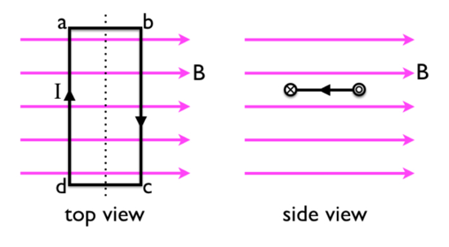
4. Sides of ab and cd feel no force at all for the picture above because they are parallel to the magnetic field
5. The sides bc and da experience force but these forces cancel out
6. End result is that net force is zero
7. However, there is a non-zero net torque acting on the loop
8. In the side view, the force on the left side is directed down, while torque on the right side is directed up, leading to a counter-clockwise torque that makes the loop rotate
9. As loop rotates about dashed line shown in top view, forces on long sides of the loop are unchanged, but net torque decreases as the forces come closer to being along the same line
10. After rotation by 90 degrees, the net torque drops to 0 and at this point, if we reverse the direction of current, then when loop goes beyond degrees, the torque will still be counterclockwise
11. This is the DC motor: torque on the loop makes loop rotate and reversing the current direction every half rotation of loop keep the torque in same direction, so that the loop is keep spinning
12. Torque when loop has width w and length L:

T=rF\*sin(theta) = w/2\*ILB

1. There are two of these:

Tnet=w/2\*2\*ILB = IwLB = IAB (where A is the area of the loop)

Tnet=IAB\*sin(theta)

Where theta is the angle between area vector of the loop and magnetic field